**A Project On**

**Deep Convolutional Generative Adversarial Neural Network**

**Submitted to:**

Dr. Amjad Ali

**Submitted by:**

Farheen Qaiser Mphil-23F-02

**Deep Learning With Neural Networks**

Centre For Advanced Studies in Pure And Applied Mathematics



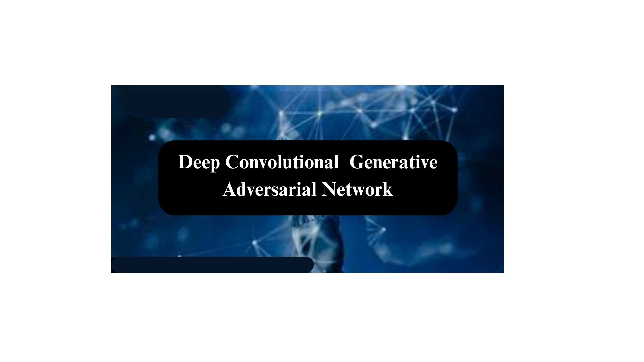

# Abstract

Deep Convolutional Generative Adversarial Networks (DCGANs) have emerged as a powerful framework for generating realistic images through adversarial training. However, training DCGANs effectively remains a challenging task due to issues such as mode collapse, vanishing gradients, and instability. we propose a comprehensive approach for solving the challenges associated with DCGANs.

This abstract provides an overview of the key components and training procedures of DCGANs, highlighting their potential applications in image generation, data augmentation, and artistic expression.

**Architecture**

DCGANs consist of two neural networks,

* **Generator.**
* **Discriminator.**

They are trained simultaneously in a competitive manner.

The generator learns to produce synthetic samples that are indistinguishable from real data, Through adversarial training, DCGANs can produce high-quality images across various domains, including but not limited to faces, animals, and landscapes.

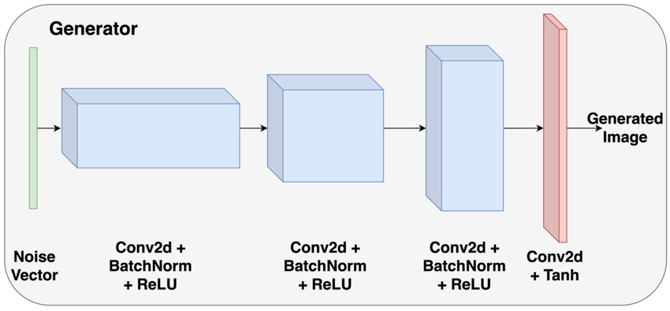

In a DCGAN (Deep Convolutional Generative Adversarial Network), the discriminator plays a crucial role in distinguishing between real and generated images. The discriminator is a convolutional neural network (CNN) designed to classify images as real or fake. It takes an input image and passes it through multiple layers of convolutional and pooling operations, followed by fully connected layers. These operations help the discriminator learn and extract features from the input image. The discriminator learns to distinguish between real data set (images) and fake data set (images).

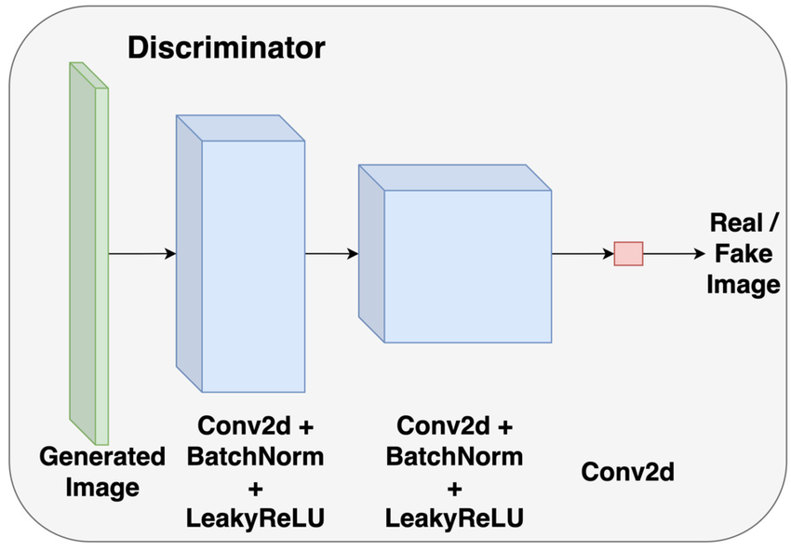

**Training**

During training, the discriminator is presented with both real and generated images. Its task is to correctly classify the real images as real and the fake images as fake. The output of the discriminator is a probability score, indicating the perceived authenticity of the image. The discriminator's objective is to maximize this score for real images and minimize it for fake images. As training progresses, the generator network in the DCGAN tries to generate more realistic images that fool the discriminator. This creates a competition between the generator and the discriminator, where both networks continually improve their performance. Ultimately, the generator aims to generate images that are indistinguishable from real images, while the discriminator strives to become better at detecting generated images. In summary, the discriminator in DCGANs acts as the "adversary" to the generator, providing feedback on the quality of generated images and helping the generator network improve over time

**Objective**

The objective of utilizing deep convolutional generative adversarial networks (DCGANs) is to develop a robust and efficient framework for generating high-quality synthetic data in various domains. By leveraging the power of adversarial training, DCGANs aim to learn the underlying distribution of the training data and produce realistic samples that are perceptually indistinguishable from real data.

**Algorithm**

An algorithm for training a Deep Convolutional Generative Adversarial Network (DCGAN) involves several key steps. Here's a high-level outline of the algorithm:

1. Import Important libraries
2. Specifying image location
3. Displaying real images
4. Initialize the Generator (G) and Discriminator (D) Networks
5. Training Loop
6. Visualization and Evaluation
7. Adjust hyperparameters
8. Repeat Steps 5-7 Until Convergence
9. Save Model

**Applications of DCGANs**

1. Image Generation
2. Image-to-Image Translation
3. Medical Image Analysis
4. Fashion and Design
5. Drug Discovery

**Limitations and Challenges**

While DCGANs (Deep Convolutional Generative Adversarial Networks) have shown impressive results in generating realistic images, they do have some challenges and limitations. Here are a few:

1. **Mode Collapse**: One common challenge is mode collapse, where the generator produces limited variations in generated images, focusing on a subset of the target distribution. As a result, the generated samples might lack diversity and exhibit repetition.

2. **Training Instability**: DCGANs can sometimes be challenging to train. They require careful tuning of hyperparameters, such as learning rates and network architectures, to ensure stable learning. Unstable training can lead to the generator and discriminator networks not effectively learning from each other, resulting in poor quality outputs.

3. **Evaluation Metrics**: Assessing the quality of generated images can be subjective, as it may not always align with human perception. Traditional evaluation metrics like Inception Score and Frechet Inception Distance have limitations in capturing all aspects of image quality, such as semantic correctness and visual realism.

4. **Sensitive to Input Data**: DCGANs heavily rely on the quality and diversity of the training dataset. If the dataset is inadequate or biased, the generated samples may reflect those limitations. Additionally, generating high-resolution images requires a large amount of high-quality training data, which can be difficult to obtain.

5. **Limited Global Understanding**: DCGANs focus on generating local image details rather than capturing global context. As a result, generated images might lack coherent structures or exhibit unrealistic deformations.

6. **Interpretability and Control**: Understanding and controlling specific attributes of generated images, such as pose, lighting, or appearance, can be challenging. DCGANs have limited explicit control over these factors during the generation process. Despite these challenges, DCGANs have made significant advancements in generative models and continue to be an active area of research, with ongoing efforts to overcome these limitations and improve their performance.

**Conclusion**

The conclusion of solving a Deep Convolutional Generative Adversarial Network (DCGAN) has demonstrated remarkable capabilities in generating high-quality synthetic data across various domains, including images of faces, animals, and landscapes. They have been instrumental in advancing research in image generation, data augmentation, and artistic expression. DCGANs have shown potential applications in tasks such as image super-resolution, image-to-image translation, and anomaly detection.